**Application form for 8 to 16 year olds with existing instrumental skills**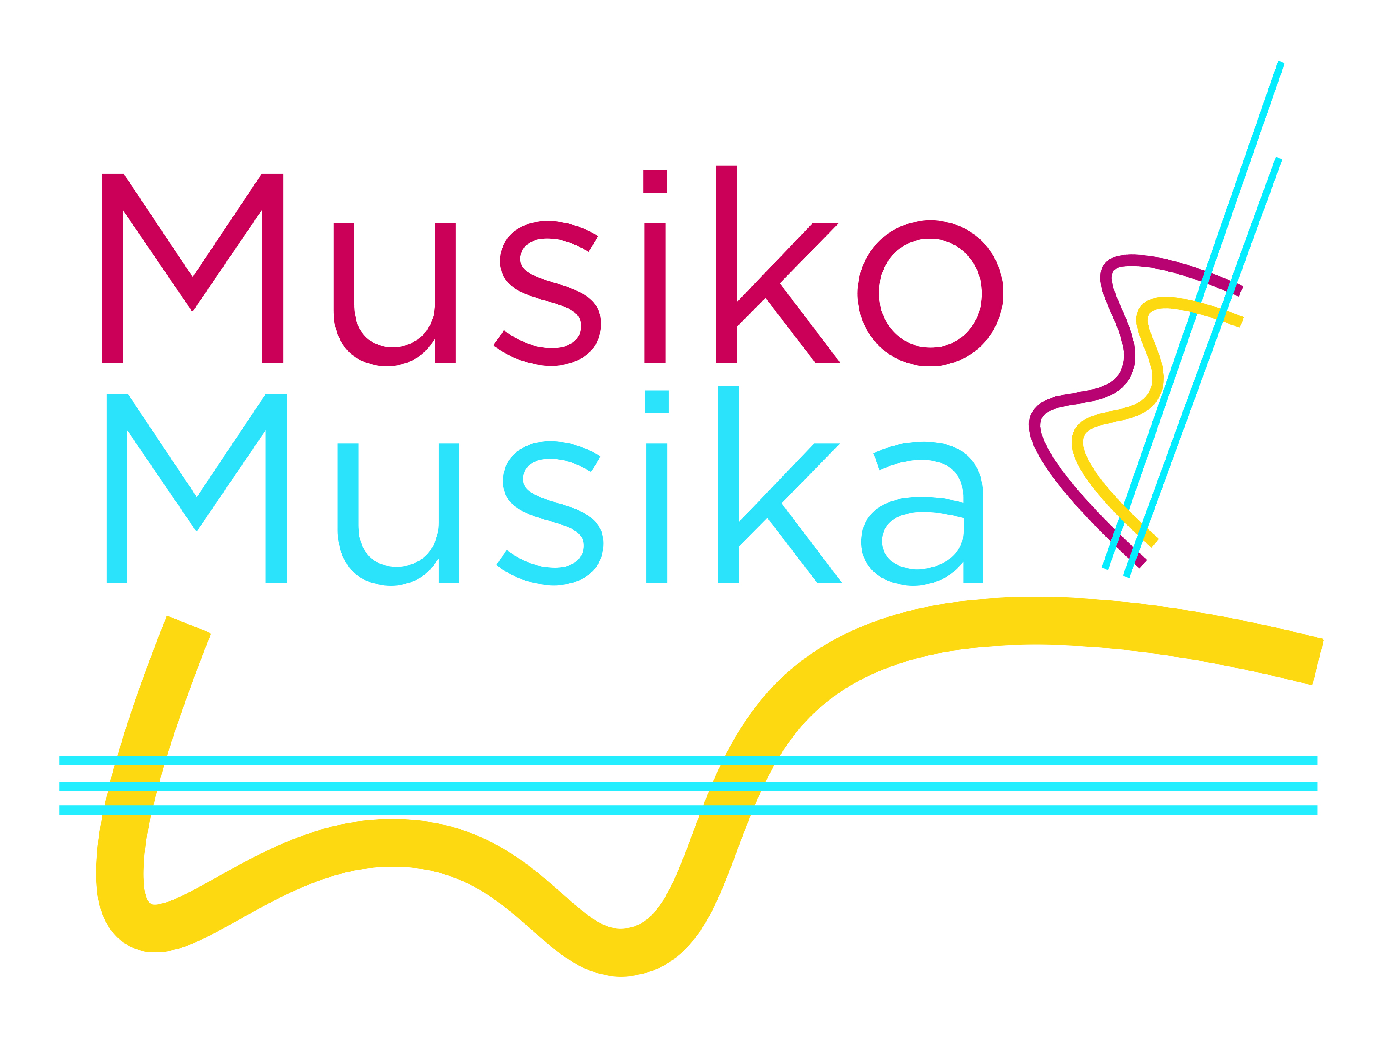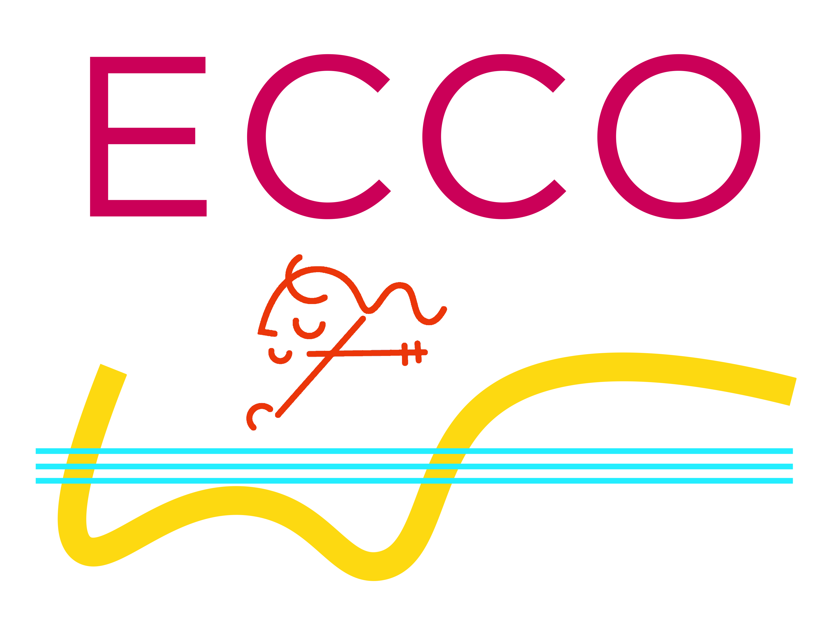

**1) Details of child/ young person applying**

Full name ________________________________________

Date of birth ______/______/______ Age ______

Name of parent/ carer ______________________________

Address ________________________________________________________

Postcode ________________

Contact phone number _________________________________

Contact email address _____________________________________________

**2) About your musical interests and skills**

Tell us about any musical skills you already have or instruments you are learning

_________________________________________________________________

Why are you interested in joining the ECCO project?

_________________________________________________________________

_________________________________________________________________

Do you have any additional needs or access requirements that you would like to tell us about?

_________________________________________________________________

**Parent/ carer signature** __________________________ **Date** _______

*Email this completed application form to info@musikomusika.org*

**ECCO Project**

**Application Form 2022-23**